**6.WebApi_Handson**

**TASK 1 :** Create a Chat Application which uses Kafka as a streaming platform and consume the chat messages in the command prompt.

**Program.cs**

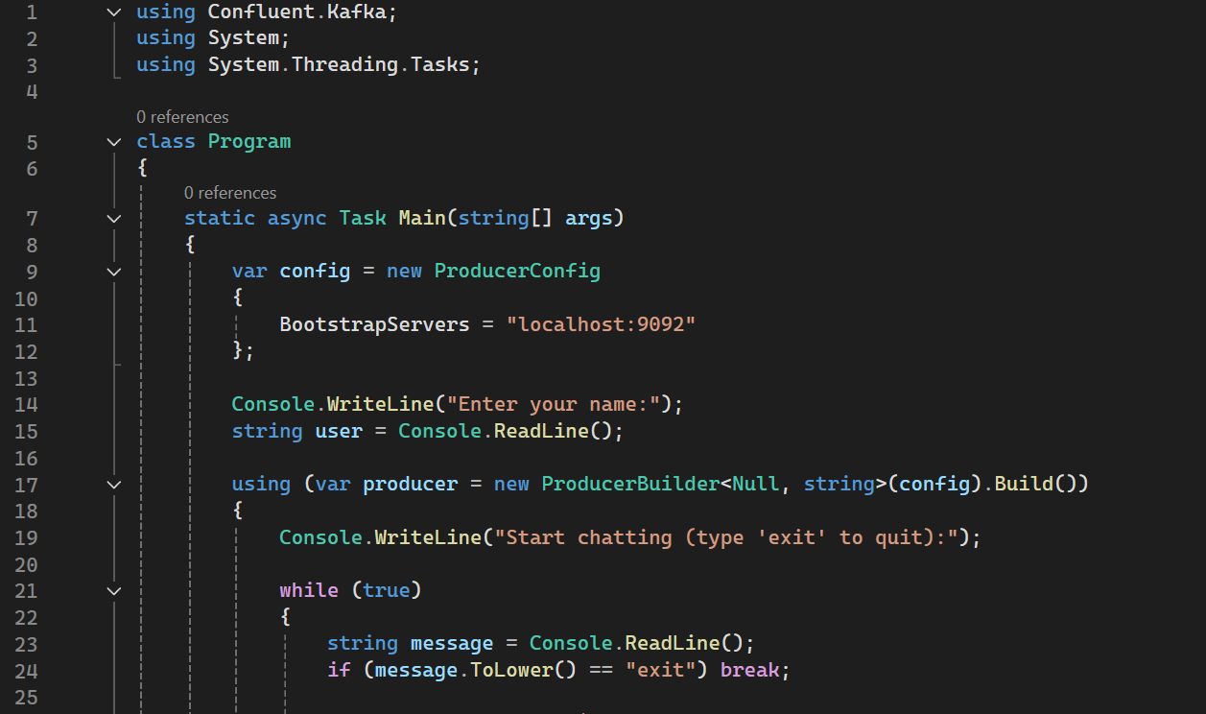 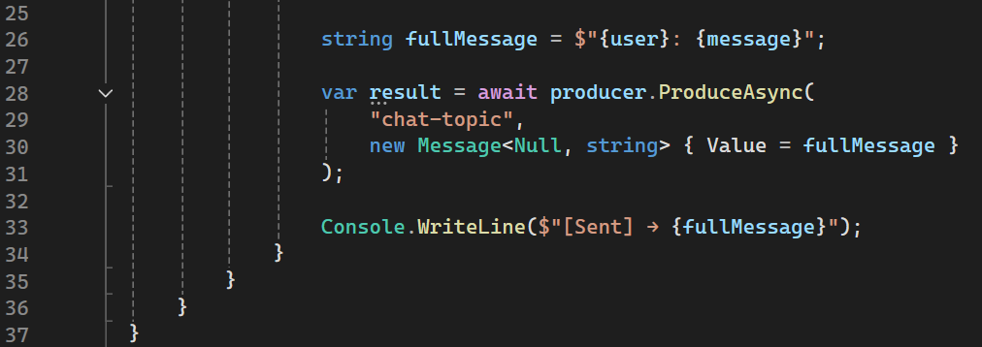

**OUTPUT:**

consumes the chat messages in the command prompt.

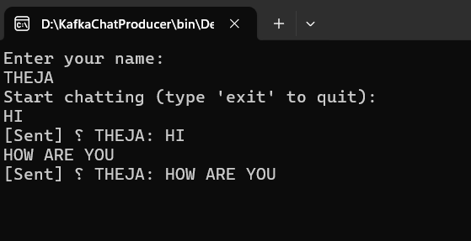

**TASK 2:** Create a Chat Application using C# Windows Application using Kafka and consume the message in different client applications.

**ProducerApp**

Program.cs

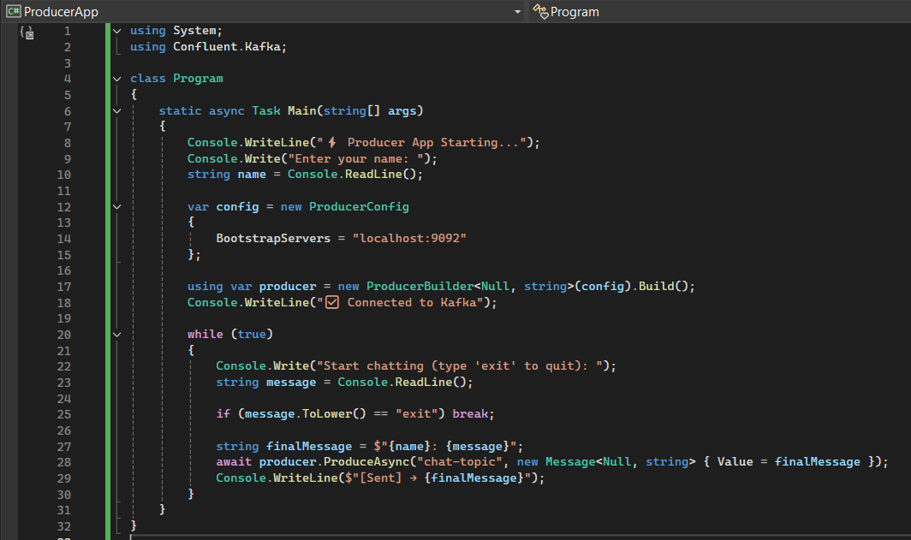

ConsumerApp

Program.cs

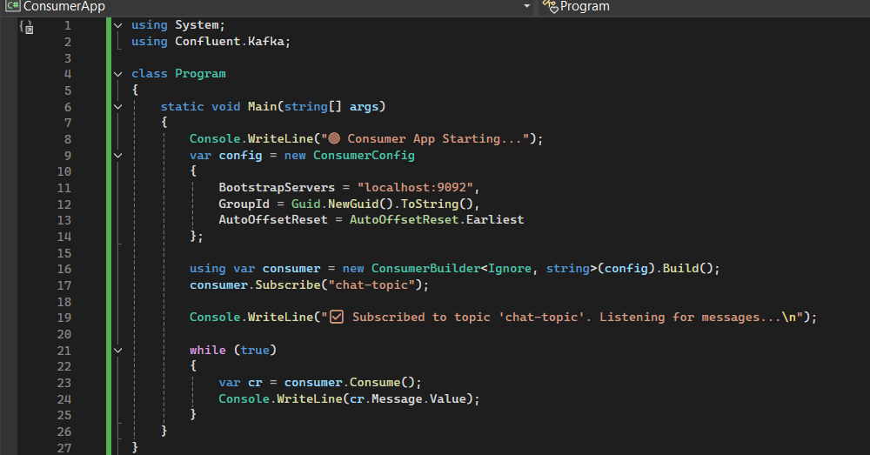

**OUTPUT:**



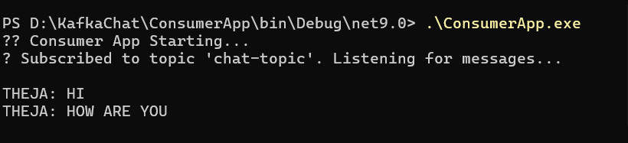

**Authentication and Authorization in ASP.NET Core Web API Microservices Hands-On Exercises**

**TASK 1: Implement JWT Authentication in ASP.NET Core Web API**

**Program.cs**

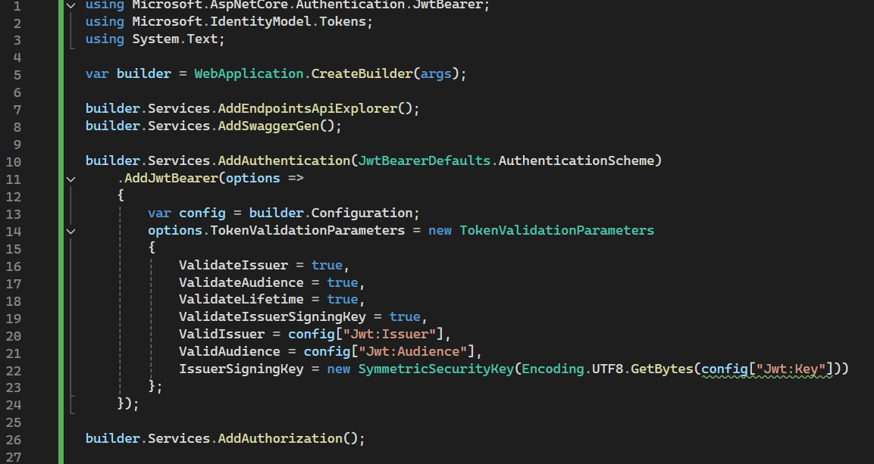

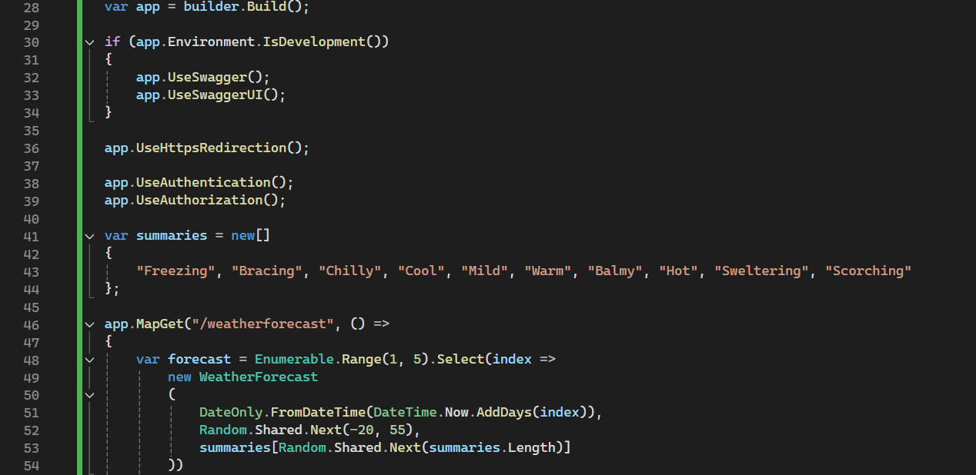

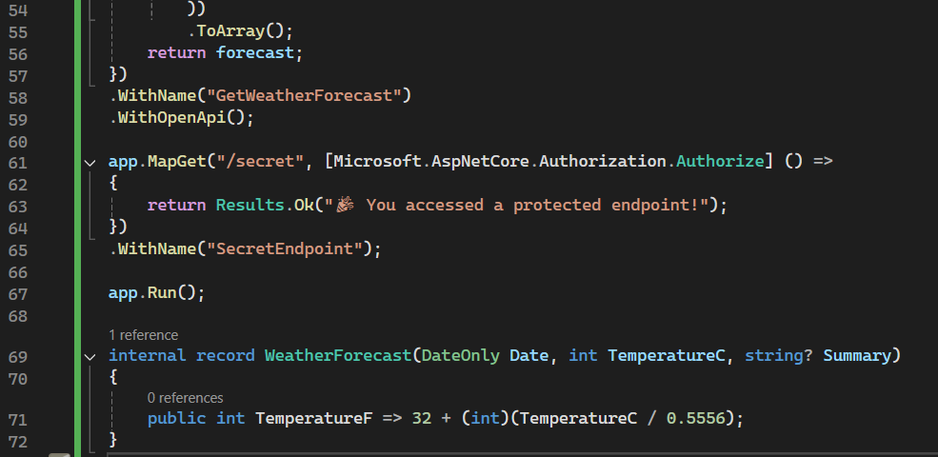

**AuthController.cs**

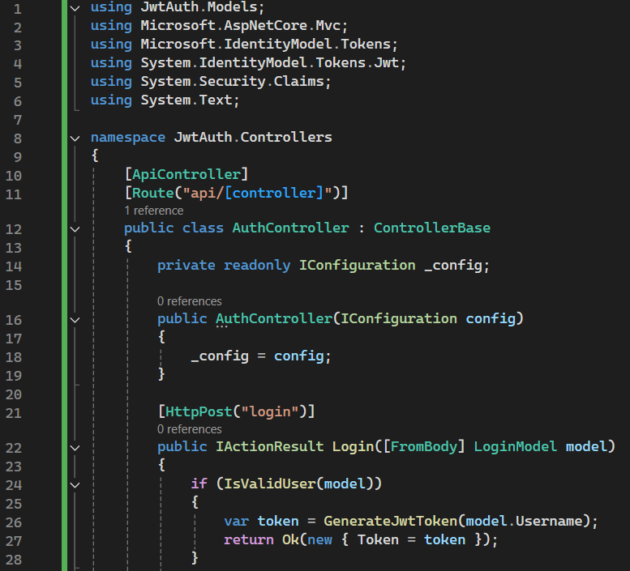

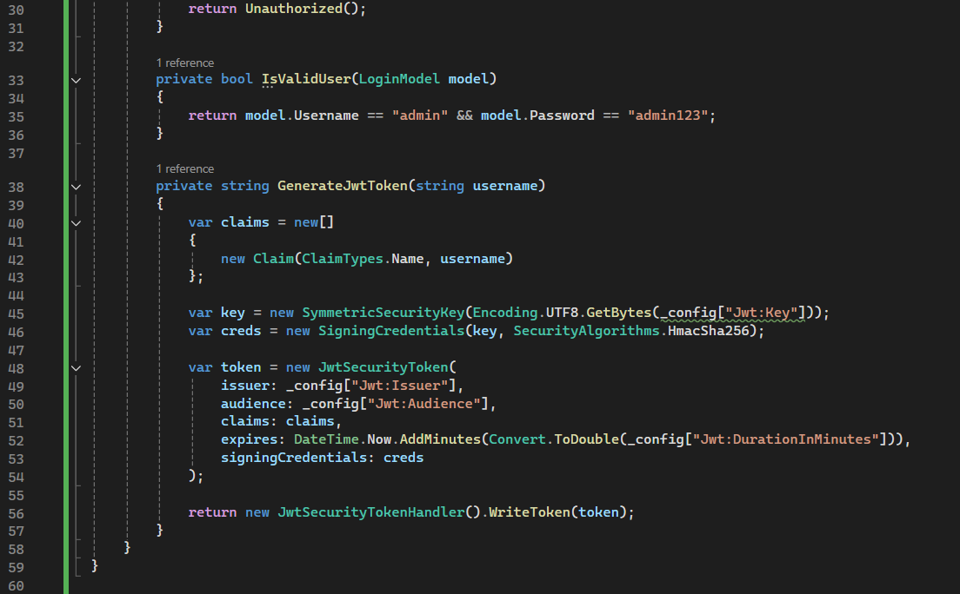

**appsettings.json**

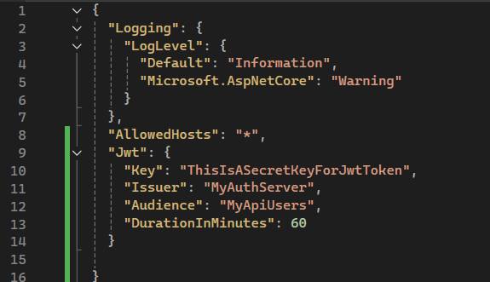

**LoginModel.cs**

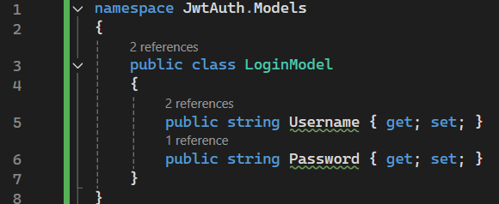

**OUTPUT:**

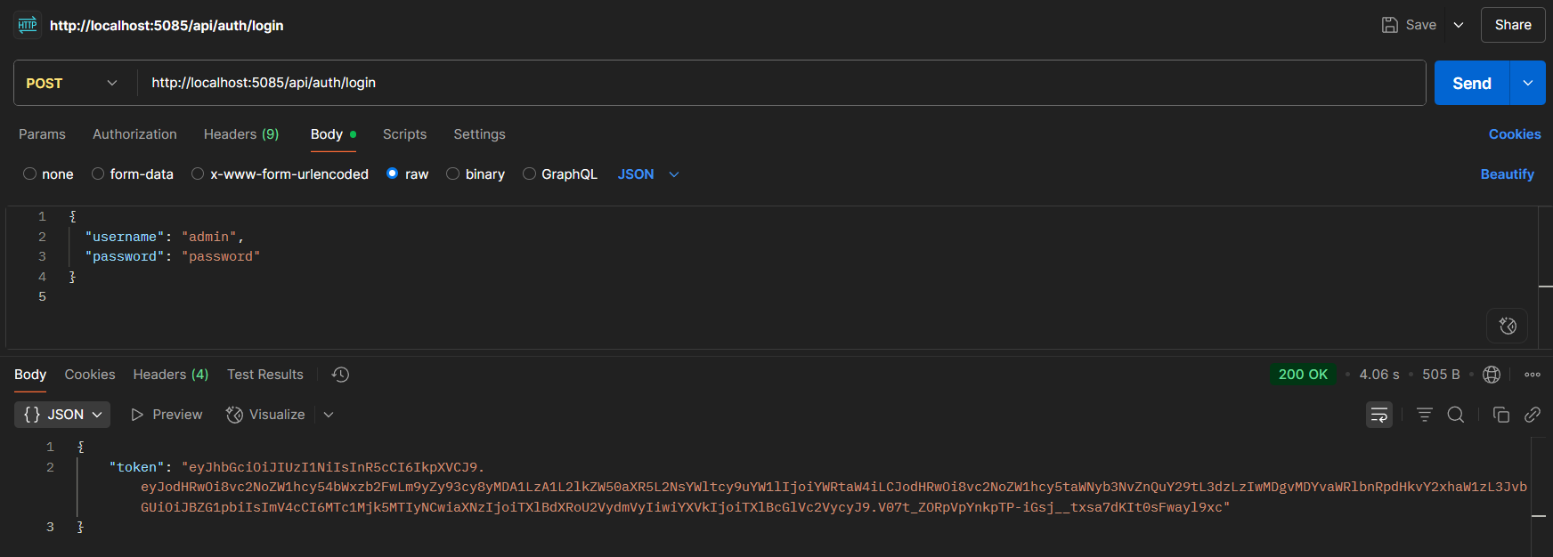

**TASK 2: Secure an API Endpoint Using JWT**

**Scenario:**

You want to restrict access to a sensitive endpoint using JWT authentication.

**Steps:**

1. Add `[Authorize]` to a controller.

2. Test access with and without a valid token.

Program.cs

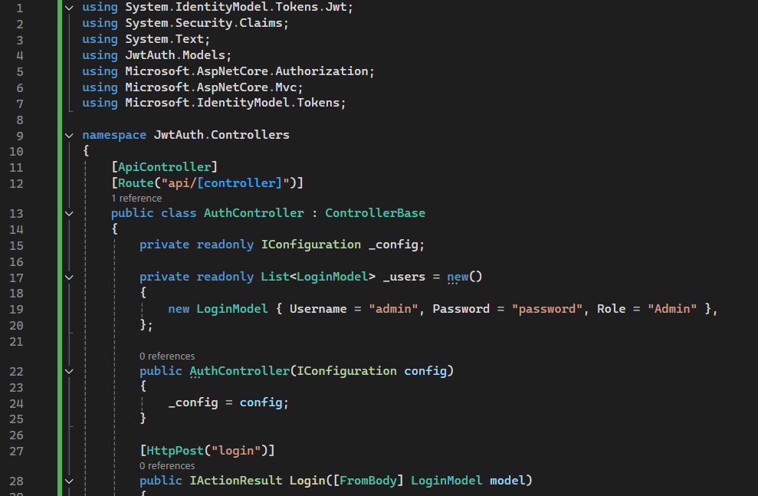

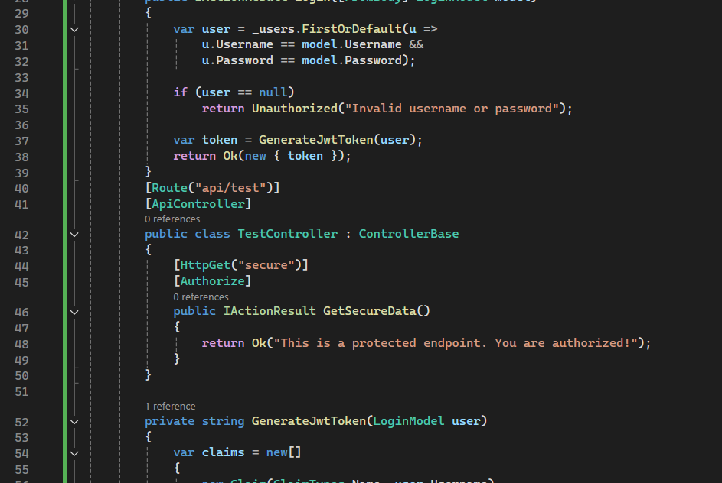

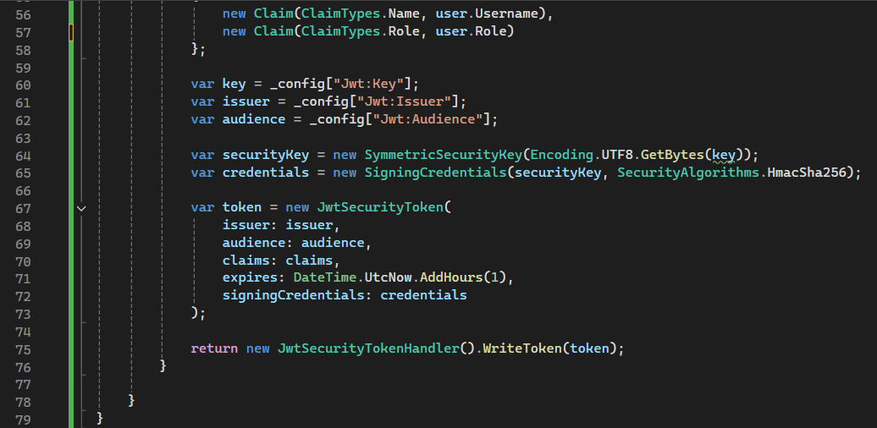

**OUTPUT:**

**With Header**

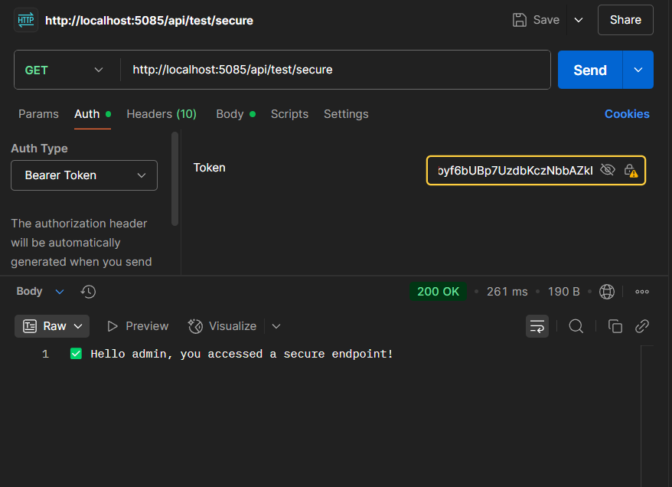

**Without header**

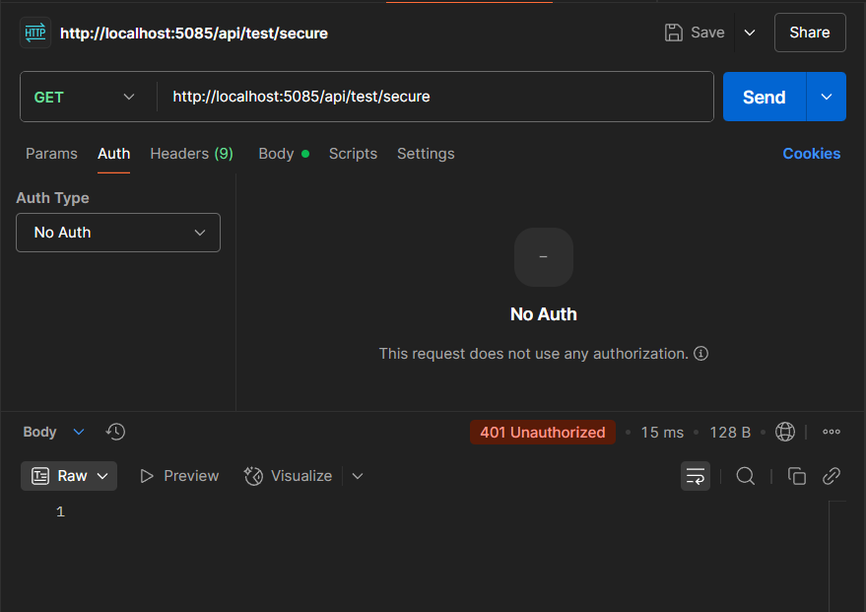

**TASK 3:** **Add Role-Based Authorization**

**Scenario:**

You want to allow only users with the "Admin" role to access certain endpoints.

**Steps:**

1. Add roles to JWT claims.

2. Use `[Authorize(Roles = "Admin")]`.

**OUTPUT:**

**i)Admin**

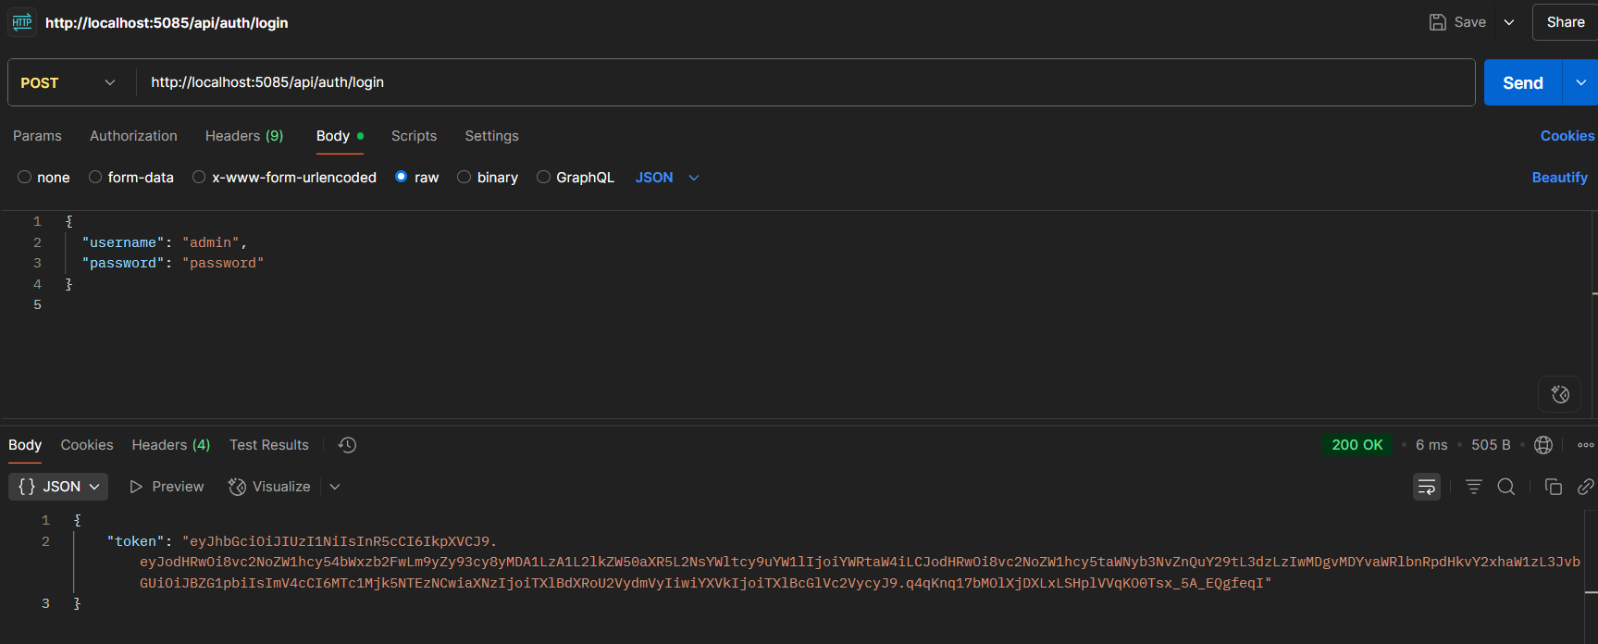

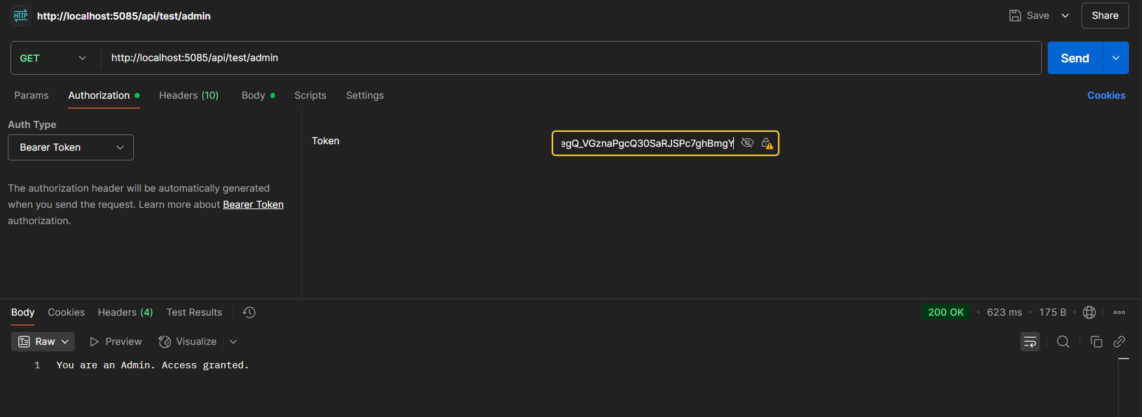

**ii)poc**

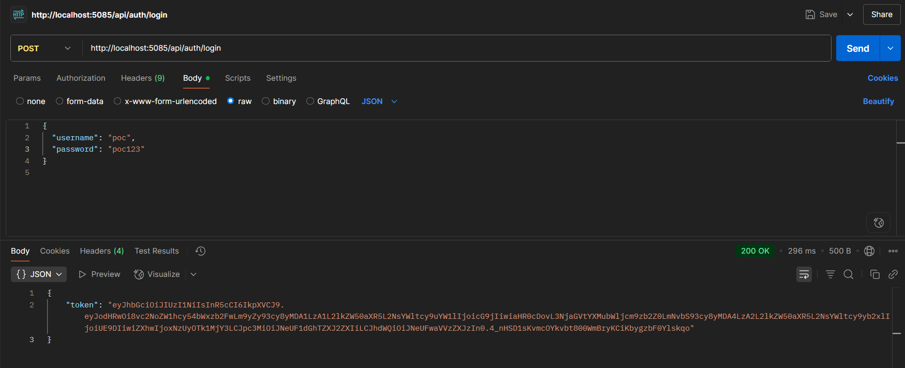

**iii)user**

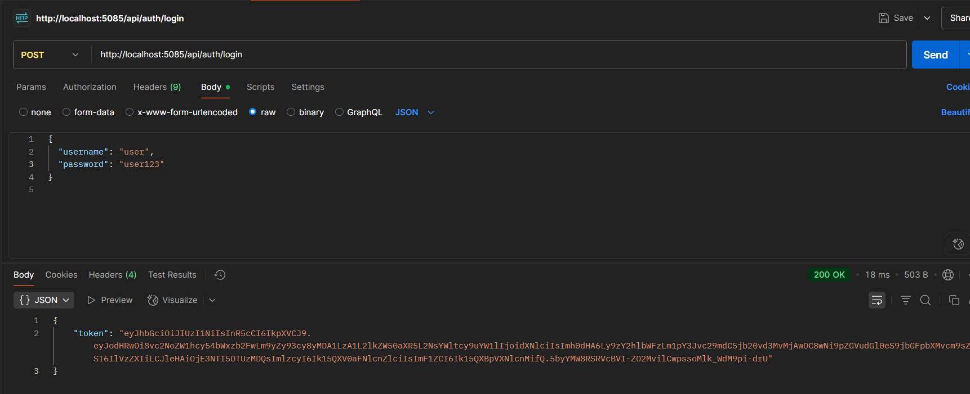

**TASK 4:** Validate JWT Token Expiry and Handle Unauthorized Access Scenario: You want to handle expired or invalid tokens gracefully.

Steps:

1. Configure JWT bearer events.

2. Return custom messages for unauthorized access.

**Program.cs**

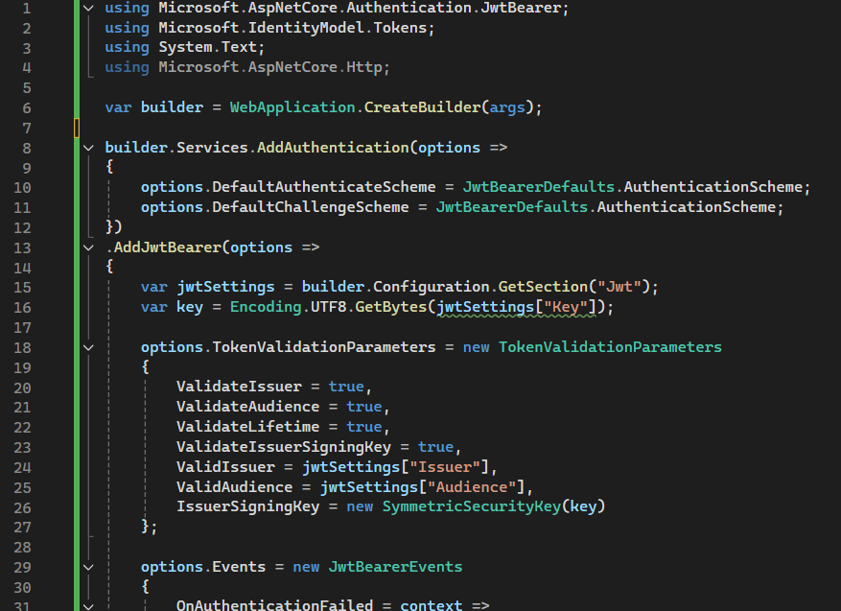

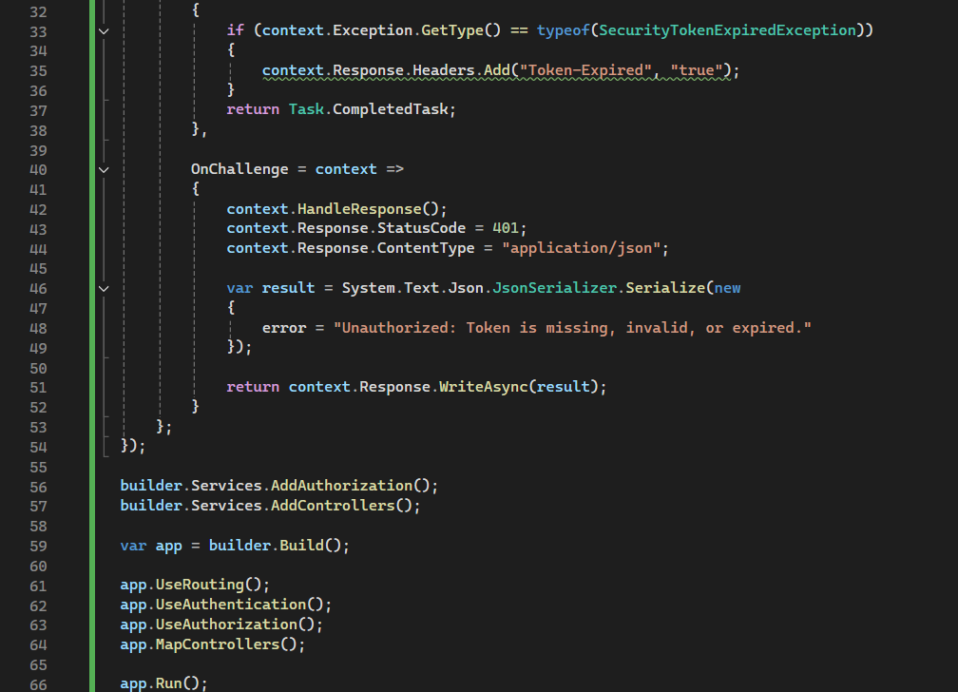

**appsettings.json**

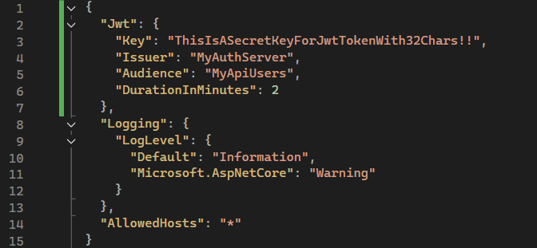

**OUTPUT:**

For Unauthorized User login:

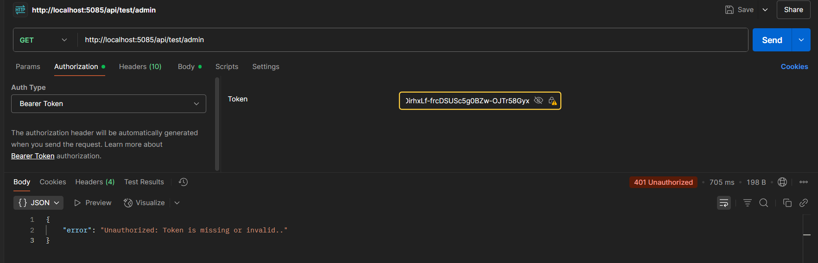

Token Before expiring:

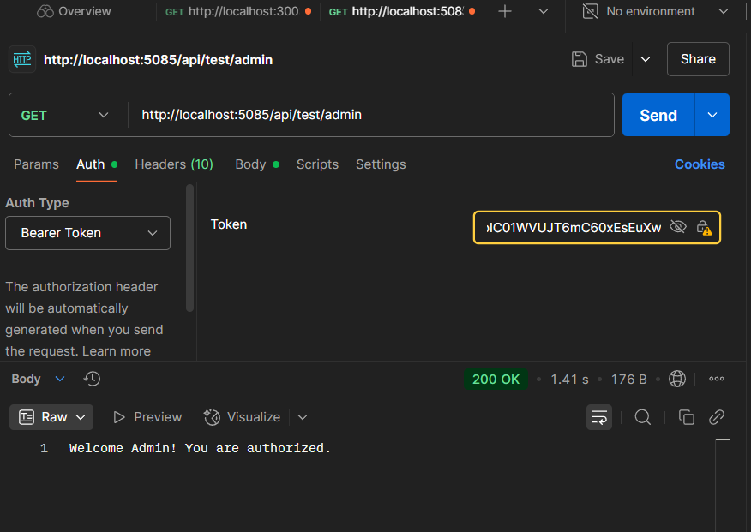

Token after expiring: 